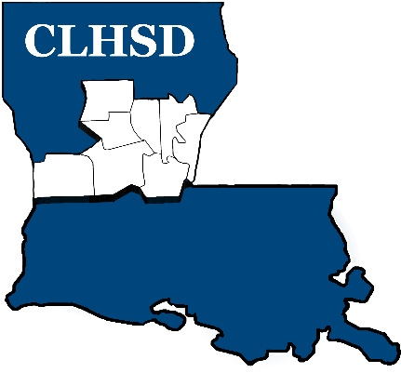

PUBLIC NOTICE

The Board of Directors of Central La Human Services District will conduct its monthly meeting on:

Thursday, July 4th, 2024
5:30 p.m.

CLHSD ~ Conference Room
5411 Coliseum Blvd
Alexandria, LA 71303

The meeting is open to the public

